**STYLE GUIDE**

**Pages:**

1. Home Page (Landing Page)

* Has a search bar to search movies
* Show top movies showing
* A bar for different genres to click on and pages on movies for the specific movies to choose from

1. List of shows/movies watched

* Shows/movies that was clicked as already watched

1. List of shows/movies want to watch

* Show/movies that was clicked as want to watch

1. Login
2. Genre pages

**Web Map:**

**Header:**

* Same on all pages
* Background: RGB(43,52,103), grid display to balance the side bar icon with the title in the middle
* Title: GoodStreams
  + Font: Righteous, pink - RGB(235,69,95), 50px, centered, weight is 700
* Icon

  Description automatically generatedicons: pink color, included with the header each time
  + When hovered, the background is pink and the lines are navy

**Side nav bar:**

* Same on all pages
* When the icon is not pressed
  + The height is 100% but the width is 0
  + It is hidden, display is none and background is purple RGB(68,60,104)
  + the menu lists have font-size of 25px, font is Righteous and color is pink
* When the icon is pressed
  + The width of the nav is 300px
  + It moves the whole body to the left by 300px margin
  + Icon

    Description automatically generated The X icon shows up with inline-block display and the 3 bar icon disappears with display as none
  + Transitions 0.5s
* When the X icon is pressed, the side nav bar closes
* The menu items uses the font Righteous and color is pink
* When you hover over the menu items
  + The background of the menu item is beige with RGB(252,255,231)
  + The words are purple and underlines

**Footer:**



* Same on all pages
* Background is navy
* Width is 100% with padding 2%
* The text is centered and color is pink

**Body:**

* Background color is light blue
* Minimum height is 100vh to keep the footer at the bottom of the page
* Display flex and column

**Home Page:**

* Search for movies to watch heading before the search bar
  + Font: Changa One, color pink, weight 100
  + Centered and 0 margins
* Search bar
  + Form has flex-direction row, display is flex
  + Width is 500px, background is beige and border-radius 20px to make the edges round
  + Centered and margin 10px at the top
  + Place holder: “Search…”
    - Color pink and opacity 0.7
  + Search icon
    - font size is 35px and padding to the right is 5px
    - If hovered, background is transparent, we don’t want the pink background like other icons



* Genres Nav bar
  + - Background beige and texts centered
    - Font is righteous, and font-weight 50px, font size 22px, no list style, color pink
    - Display inline and padding 10px
    - When hovered, they are purple and underlined
  + Home page automatically show the Top 50 movies

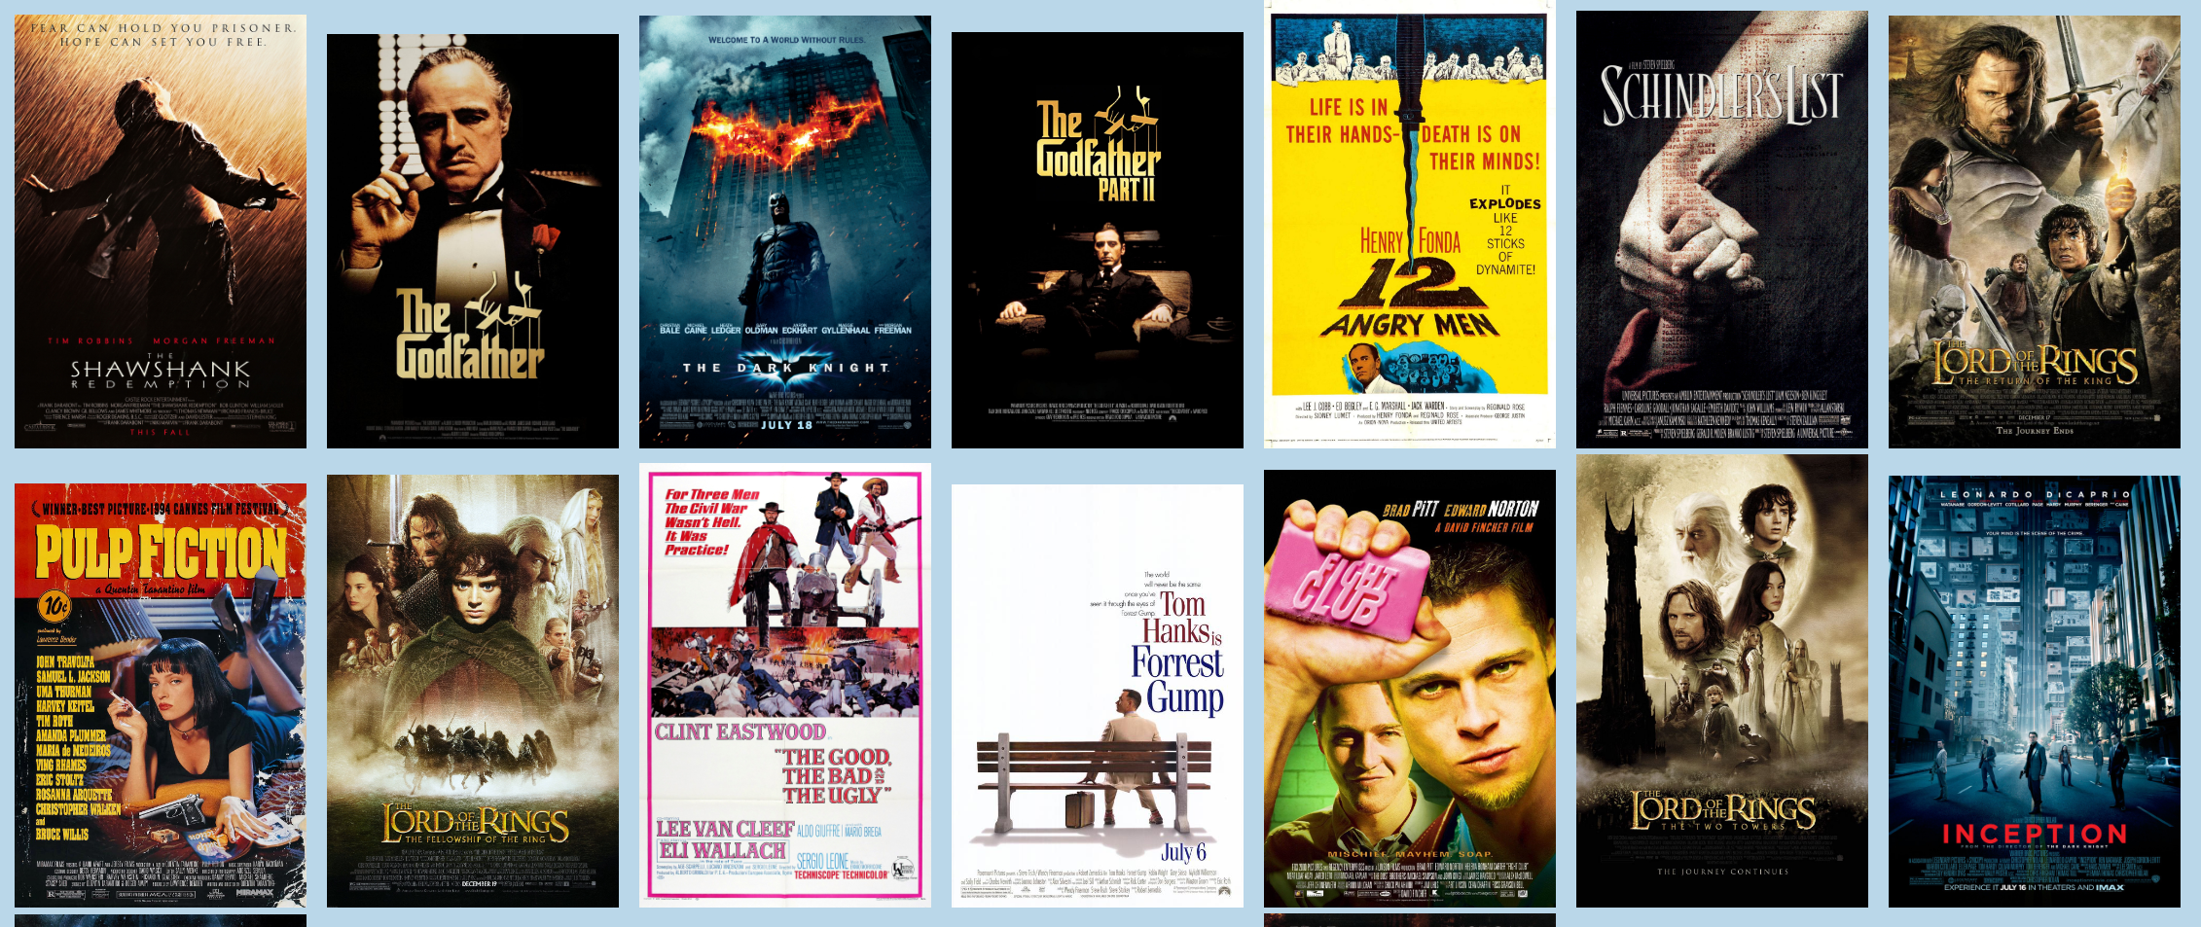

* + Images are in the center in an inline flex and wraps over
  + Images of movies depending on what you selected in the nav bar
    - Images inline-block display
    - Width 200px, height 10%
    - Object-fit is fill
    - Hover over images, opacity is 80%
    - And when hovered over image, there are 3 buttons that shows up: info, watched, and want to watch
      * Items centered
      * When not hovered over image, display is none
      * Background color of buttons: beige, font color: navy
      * Border-radius is 10px and opacity 100%
      * A picture containing text, outdoor, sign

        Description automatically generatedWhen buttons are hovered over, the background color is pink and font color beige
      * The info button is translated by X:0 and Y:-650%
      * Wan to watch button is translated by X:0% and Y:-400%
      * Watched button is translated by X:0% and Y:-300%

**Login and Registration:**

* The input fields are set to display as inline blocks.
* The width of the input fields is set to 90% of the available space.
* The input fields have a top and bottom margin of 8px.
* The left and right padding of the input fields is set to 12px and 22px, respectively.
* The input fields have a 3px solid border with a color of #EB455F (red-pink).
* The box-sizing property is set to border-box to ensure that the border and padding are included in the width of the input fields.

**Responsive Display:**

* for body, it is no wrap and items alignment are stretched
* The header is a block instead of a grid so that the side bar icon is at the top and each elements goes to the next line
* The side bar icon is flex and it is placed in the center
* The forms width is 250px